**IS 306 Data Management Communications and Networking**

**HOP06 – Basic Networking**

1/6/2019 Developed by Clark Ngo

Center for Information Assurance (CIAE) @City University of Seattle (CityU)

**Before You Start**

* Version numbers may not match with the most current version at the time of writing. If given the option to choose between stable release (long-term support) or most recent, please choose the stable release rather than beta-testing version.
* This tutorial targets Windows users and MacOS users.
* There might be subtle discrepancies along the steps. Please use your best judgement while going through this cookbook style tutorial to complete each step.
* For your working directory, use your course number. This tutorial may use a different course number as an example.
* The directory path shown in screenshots may be different from yours.
* If you are not sure what to do or confused with any steps:
  1. Consult the resources listed below.
  2. If you cannot solve the problem after a few tries, ask a TA for help.

**Learning Outcomes**

Students will be able to:

* ping

**Resources**

* MacOS Network Commands – <https://gree2.github.io/mac/2015/07/18/mac-network-commands-cheat-sheet>
* Traceroute – <https://www.pcwdld.com/what-is-traceroute>

**Preparation**

**For MacOS, open your Terminal**

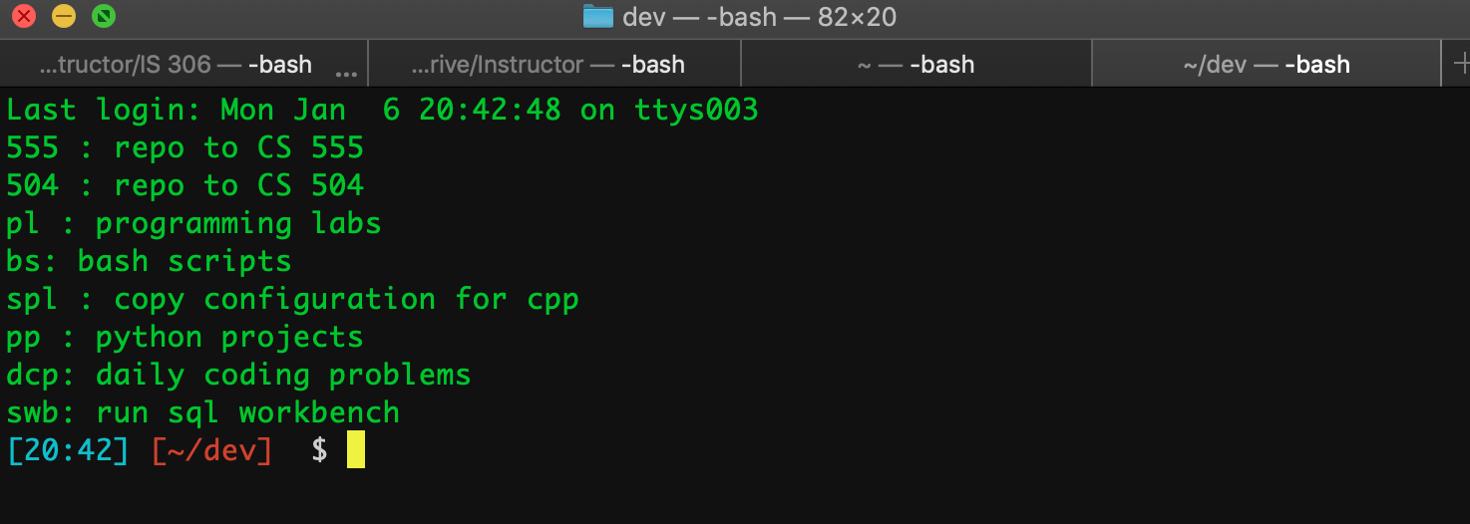

**For Windows, open your Command Prompt**

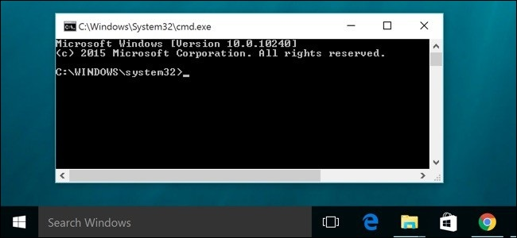

**Ping (Packet Internet Groper)**

**Testing the reachability of the host**

**ping *ip_address***

**ping *website_name***

Note: to stop the ping command, hit Ctrl + C

ping www.google.com

PING www.google.com (216.58.193.68): 56 data bytes

Request timeout for icmp_seq 0

64 bytes from 216.58.193.68: icmp_seq=1 ttl=54 time=12.303 ms

64 bytes from 216.58.193.68: icmp_seq=2 ttl=54 time=30.416 ms

64 bytes from 216.58.193.68: icmp_seq=3 ttl=54 time=10.782 ms

^C

--- www.google.com ping statistics ---

4 packets transmitted, 3 packets received, 25.0% packet loss

round-trip min/avg/max/stddev = 10.782/17.834/30.416/8.919 ms

**Adding a delay for 2 seconds and 5 counts**

|  |  |
| --- | --- |
| **MacOS -i for delay; -c for count** | **Windows OS -w for delay; -n for count** |
| ping -i 2 -c 5 www.google.com | ping -w 2000 -n 5 www.google.com |

PING www.google.com (216.58.193.68): 56 data bytes

64 bytes from 216.58.193.68: icmp_seq=0 ttl=54 time=15.636 ms

64 bytes from 216.58.193.68: icmp_seq=1 ttl=54 time=16.164 ms

64 bytes from 216.58.193.68: icmp_seq=2 ttl=54 time=21.002 ms

64 bytes from 216.58.193.68: icmp_seq=3 ttl=54 time=17.972 ms

64 bytes from 216.58.193.68: icmp_seq=4 ttl=54 time=13.021 ms

--- www.google.com ping statistics ---

5 packets transmitted, 5 packets received, 0.0% packet loss

round-trip min/avg/max/stddev = 13.021/16.759/21.002/2.648 ms

**Questions you can answer for submission:**

Technical: What is the command for? Why would you use the command?

Technical: What other ping options is useful? Why?

Knowledge: Can you discuss the step-by-step process and identify the components?

**Trace**

**Display the route and measure transit delays**

|  |  |
| --- | --- |
| **MacOS** | **Windows OS** |
| traceroute www.google.com | tracert www.google.com |

**In MacOS:**

traceroute www.cityu.edu

**In Windows OS:**

tracert www.cityu.edu

Note: to stop the trace command, hit Ctrl + C

traceroute to cityu-edu.go-vip.co (192.0.66.2), 64 hops max, 52 byte packets

1 192.168.0.1 (192.168.0.1) 6.059 ms 1.468 ms 1.395 ms

2 96.120.102.233 (96.120.102.233) 11.385 ms 13.556 ms 14.923 ms

3 96.110.250.9 (96.110.250.9) 14.148 ms 12.654 ms 11.024 ms

4 69.139.161.118 (69.139.161.118) 10.894 ms 10.662 ms 11.360 ms

5 68.86.96.157 (68.86.96.157) 13.807 ms 12.512 ms 12.176 ms

6 be-33650-cr01.seattle.wa.ibone.comcast.net (68.86.93.165) 20.820 ms 21.096 ms 15.298 ms

7 be-10847-pe02.seattle.wa.ibone.comcast.net (68.86.86.226) 12.990 ms 13.455 ms 25.259 ms

8 as7018-pe01.1950stemmons.tx.ibone.comcast.net (75.149.231.26) 12.705 ms 12.284 ms 11.700 ms

**Questions you can answer for submission:**

Technical: What is the command for? Why would you use the command?

Technical: What other trace options is useful? Why?

Knowledge: Can you discuss the step-by-step process and identify the components?

**Network Configuration**

**Display network interfaces**

**ifconfig** is a system administration utility in Unix-like operating systems for network interface configuration.

**ipconfig** (internet protocol configuration) is a console application of some operating systems that displays all current TCP/IP network configuration

|  |  |
| --- | --- |
| **MacOS** | **Windows OS** |
| ifconfig | ipconfig |

lo0: flags=8049<UP,LOOPBACK,RUNNING,MULTICAST> mtu 16384

options=1203<RXCSUM,TXCSUM,TXSTATUS,SW_TIMESTAMP>

inet 127.0.0.1 netmask 0xff000000

inet6 ::1 prefixlen 128

inet6 fe80::1%lo0 prefixlen 64 scopeid 0x1

nd6 options=201<PERFORMNUD,DAD>

gif0: flags=8010<POINTOPOINT,MULTICAST> mtu 1280

stf0: flags=0<> mtu 1280

XHC20: flags=0<> mtu 0

en0: flags=8863<UP,BROADCAST,SMART,RUNNING,SIMPLEX,MULTICAST> mtu 1500

ether a0:99:9b:0f:70:a5

inet6 fe80::c1b:291e:784e:50f%en0 prefixlen 64 secured scopeid 0x5

inet6 2601:600:947f:df90:1039:d5c5:2541:7b08 prefixlen 64 autoconf secured

inet6 2601:600:947f:df90:210a:c788:789f:ffa4 prefixlen 64 autoconf temporary

inet 192.168.0.11 netmask 0xffffff00 broadcast 192.168.0.255

nd6 options=201<PERFORMNUD,DAD>

media: autoselect

status: active

**Questions you can answer for submission:**

Technical: What is the command for? Why would you use the command?

Technical: What other ipconfig options is useful? Why?

Knowledge: Can you discuss the step-by-step process and identify the components?

**Network Configuration**

**IP Address**

|  |  |
| --- | --- |
| **MacOS** | **Windows OS** |
| ipconfig getifaddr en0 | ipconfig  ipconfig | findstr IPv4 |

192.168.0.11

**Subnet Mask**

|  |  |
| --- | --- |
| **MacOS** | **Windows OS** |
| ipconfig getoption en0 subnet_mask | ipconfig  ipconfig | findstr Subnet |

255.255.255.0

**Domain Name Server**

|  |  |
| --- | --- |
| **MacOS** | **Windows OS** |
| ipconfig getoption en0 domain_name_server | ipconfig  ipconfig | findstr Default |

75.75.75.75

**Questions you can answer for submission:**

Technical: What is the command for? Why would you use the command?

Technical: What other options is useful? Why?

Knowledge: Can you discuss the step-by-step process and identify the components?